

ARTICLE IN PRESS

Engineering Applications of Artiﬁcial Intelligence 16 (2003) 607–613

Neural network model for rapid forecasting of freeway
link travel time

Abhijit Dharia, Hojjat Adeli*
Departments of Biomedical Informatics, Civil and Environmental Engineering and Geodetic Science, and Neuroscience, The Ohio State University,
470 Hitchcock Hall, 2070 Neil Avenue, Columbus, OH 43210, USA
Accepted11 September 2003

Abstract

Estimation of freeway travel time with reasonable accuracy is essential for successful implementation of an advanced traveler
information system (ATIS) for use in an intelligent transportation system (ITS). An ATIS consists of a route guiding system
that recommends the most suitable route based on the traveler’s requirements using the information gathered from various
sources such as loop detectors and probe vehicles. This information can be disseminated through mass media or on on-board
satellite-basednavigational system. Basedon the estimatedtravel times for various routes, the traveler can make a route choice.
In this article, a neural network model is presented for forecasting the freeway link travel time using the counter propagation
neural (CPN) network. The performance of the model is compared with a recently reported freeway link travel forecasting model
using the backpropagation (BP) neural network algorithm. It is shown that the new model based on the CPN network, and the
learning coefﬁcients proposed by Adeli and Park, is nearly two orders of magnitude faster than the BP network. As such,
the proposed freeway link travel-forecasting model is particularly suitable for real-time advanced travel information and
management systems.
r 2003 Publishedby Elsevier Ltd.

Keywords: Backpropagation; Counter propagation; Intelligent transportation systems; Neural networks; Trafﬁc engineering

1. Introduction

Recent economic andenvironmental concerns have
placedthe focus on efﬁcient andintelligent utilization of
the existing transportation infrastructure, rather than
adding to it. Traditional models of trafﬁc congestion
andmanagement lack the adaptability andsophistication
needed to effectively and reliably deal with increasing
trafﬁc volume on the freeway. Intelligent transportation
systems are intended to provide a high level of
automation in the freeway system through the use of
advanced and adaptive technologies and implementation
of advanced trafﬁc management systems (ATMS) and
advanced traveler information systems (ATIS).
Estimation of freeway travel time with reasonable
accuracy is essential for successful implementation of an
ATIS for use in an intelligent transportation system
(ITS). An ATIS consists of a route guiding system
(RGS) that recommends the most suitable route based

*Corresponding author.

0952-1976/$ - see front matter r 2003 Publishedby Elsevier Ltd.
doi:10.1016/j.engappai.2003.09.011

on the traveler’s requirements, using the information
gatheredfrom various sources such as loop detectors
andprobe vehicles. This information can be dissemi-
nated through mass media, such as radio and the
Internet, or on boardsatellite-basednavigational
system. Basedon the estimatedtravel times for various
routes, the traveler can make route choices.
The freeway network can be considered as consisting
of a number of links. A link can be a portion of the
freeway between upstream anddownstream loop
detectors. Logically, the link travel times used in the
RGS shouldbe estimatedfrom the time the driver
actually arrives at the initial point of the link. Hence,
freeway link travel times forecasting must be done over
multiple time steps or periods, particularly when the
travel time on the link under consideration is relatively
long. For such links, it is unlikely that the travel time
will remain constant over a periodof time. The success
of an RGS, however, depends on its ability to predict
the anticipatory link travel time in addition to the
historical andreal-time link travel time.

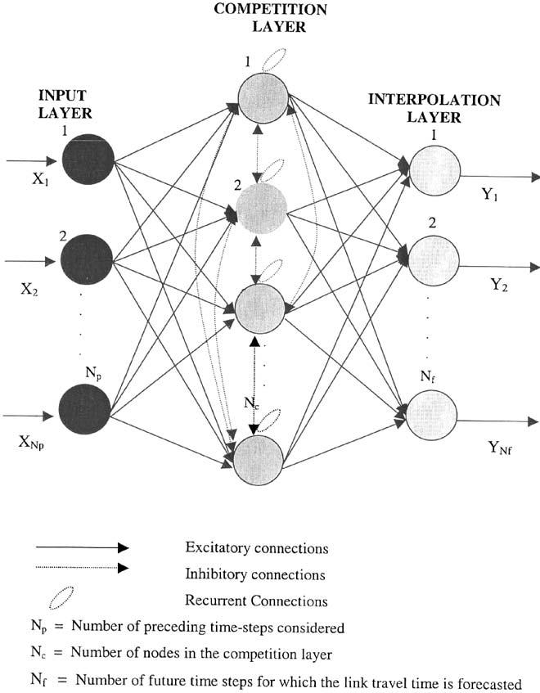
608
ARTICLE IN PRESS
A. Dharia, H. Adeli / Engineering Applications of Artiﬁcial Intelligence 16 (2003) 607–613

Traditionally, short-term freeway link travel time
has been forecast by time series models (Nihan and
Holmesland, 1980; Dailey, 1993; Van Arem et al., 1997),
Kalman ﬁltering model (Okutani andStephanedes,
1984) andhistorical andreal-time proﬁles (Boyce et al.,
1993). These models are effective for predicting the
travel time one time step aheadbut deteriorate when the
forecasting has to be done over multiple time steps (Park
andRilett, 1999).
Neural network computing appears to be a promising
approach to overcome this shortcoming. A neural
network provides a mapping between a set of inputs
andcorresponding outputs (Adeli and Hung, 1995). The
network is trainedto learn this mapping using a number
of training examples. The training is achievedby
determining the network’s weights. A review of civil
engineering applications of neural networks up to 2000
was presentedby Adeli (2001). Recent research on
transportation engineering applications of neural net-
works is presentedby Adeli and Samant (2000), Adeli
andKarim (2001), Samant andAdeli (2001), Karim and
Adeli (2002, 2003a ,b), Adeli and Jiang (2003), Jiang and
Adeli (2003), and Ghosh-Dastidar and Adeli (2003)
among other.
Recently, Park andRilett (1999) presenteda multi-
player feedforward neural network for freeway link
travel time forecasting using the backpropagation
learning rule (Rumelhart et al., 1986) for training the
network. They forecast up to ﬁve periods (time steps)
into the future with a time step of 5 min. They have
investigatedvarious input-output combinations and
concluded that ‘‘when predicting three through ﬁve time
periods into the future, the ANN models that employed
spatial data in the form of link travel times on links
immediately upstream and downstream from the target
link gave the lowest error’’ basedon a 5-min time step.
They comparedthis approach with a Kalman Filtering
model, the ALI SCOUT method(Hoffman andJanko,
1990), the historical travel time proﬁle, the real-time
travel time proﬁle, andan exponential smoothing model
(Chassakios andStephanedes, 1994) andreportedthat,
overall, the neural networks were 20% more accurate in
the forecasting of freeway link travel time as comparedto
other models that they employed for the same purpose.
Backpropagation (BP) is the most widely used neural
network model in civil engineering applications, pri-
marily due to its simplicity (Arditi et al., 1998; Cattan
andMohammadi, 1997; Deo andChaudhari, 1998;
Owusu-Ababia, 1998; Thirumalaiah andDeo, 1998).
However, backpropagation has shortcomings, including
a very slow rate of convergence andarbitrary and
problem-dependent selection of the learning and mo-
mentum ratios, as pointedout by Adeli and Hung (1994)
andothers.
In this article we present a neural network model for
forecasting the freeway link travel time using the

counter propagation neural (CPN) network anddemon-
strate its superiority over the backpropagation learning
model.

2. Counterpropagation network

CPN employs a combination of supervisedand
unsupervisedlearning (Hecht-Nielsen, 1998; Adeli and
Park, 1995, 1998). The topology of a CPN network
consists of three layers: input, competition, andinter-
polation (Fig. 1). The training of a CPN network is
carriedout in two stages. In the ﬁrst stage, the weights
of the links connecting the input layer to the competi-
tion layer are computedusing the Kohonen learning
rule. Let X denote the input vector and W_{j}denote the
weight vector for the links connecting the nodes in
the input layer to the jth node in the competition layer.
The Euclidean distance between the input vector and the
weight vector corresponding to the jth node in the
competition layer is given by
d_{j}ј W_{j}X : р1Ю
For any given training instance, a competition is
createdamong the nodes in the competition layer. The
node with the smallest Euclidean distance wins. In-
hibitory interlayer connections between the nodes in the

Fig. 1. Topology of counterpropagation neural network for freeway
link travel time forecasting.

ARTICLE IN PRESS
A. Dharia, H. Adeli / Engineering Applications of Artiﬁcial Intelligence 16 (2003) 607–613

609

competition layer are usedto conduct this competition
andset the output of the winning node to 1 andall other
nodes to 0. If the kth node is the winning node in the
competition layer, then the outputs of the nodes in the
competition layer are assignedas follows:

layer, Y_{k}is the output corresponding to the kth node in
the output layer, and b is the learning coefﬁcient. We use
the same Eq. (4), proposedby Adeli and Park (1995), to
evaluate b:
To test the learning accuracy of the CPN network we

O_{i}ј
(
0 for all nodes except the winning nodes рiakЮ;
deﬁne an error term in the following form:
1 X

1 for the winning node рi ј kЮ:

р2Ю
E ј
2
k
ЅO_{k}Y_{k}2;
р6Ю

The weight W_{ij}of the link connecting the input node
to the node in the competition layer is computed from
the Kohonen learning rule (Kohonen, 1988) as follows:
where Y_{k}and O_{k}are the actual andthe computed
outputs, respectively.

W_{ij}рn ю 1Ю ј W_{ij}рnЮ ю a X_{i}W_{ij}рnЮ O_{i}
р3Ю
3. Freeway link travel time forecasting using CPN

where n is the iteration number, X_{i}is the input
corresponding to the ith node in the input layer and a
is the learning csoefﬁcient. Hecht-Nielsen (1988) sug-
gesteda value in the range of 0 and0.8 for the learning
ratio. We use the following expression proposedby
Adeli and Park (1995):
1
a ј : р4Ю
рn ю 1Ю²
This expression provides several advantages. First, it
circumvents the arbitrary and problem-dependent selec-
tion of the learning parameter. Second, it provides a
variable value as a function of the iteration number.
Third, it ensures that the weight changes are reduced
after each iteration, thus stabilizing the weight compu-
tations andimproving the convergence performance.
This process is repeatedfor all the training instances. In
other words, the values of weights are updated after
addition of each successive training example.
It shouldbe notedthat in a CPN network only the
weights of the links fanning out of the winning nodes are
updated in every iteration (one winning node for each
training example). This is in contrast to the back-
propagation neural network, where all the weights are
updated in every iteration. In a CPN network, a winning
node for a particular training example is temporarily
deactivated for all other input patterns and is not
allowedto participate in the competition for other
training instances in the current iteration. This idea is
basedon the so-calledconscience mechanism originally
proposedby DeSieno (1988) where each node can win
only once in a single iteration of a particular training
instance.
In the secondstage of training a CPN network, the
weights of the links connecting the competition layer to
the output or interpolation layer are foundusing the
Grossberg learning rule (Grossberg, 1982):

The topology of a CPN network for forecasting the
freeway link travel time is shown in Fig. 1. The number
of nodes in the input layer is equal to the number of
preceding time intervals, N_{p}: The number of nodes in the
output layer is equal to the number of future time
intervals, N_{f}: We select the number of nodes in the
competition layer, N_{c}to be equal to the number of training
instances. We foundthat to be the minimum number of
nodes needed in the hidden (competition) layer in order to
obtain satisfactory results. Choosing a number greater
than the number of training instances for the number of
nodes in the competition layer increases the computational
costs without any improvement in accuracy. As such, we
have a logical way of selecting the number of nodes in the
competition layer. This is in contrast to the BP algorithm
where one cannot ﬁnda similar logical rule for selection of
the number of nodes in the hidden layer.

4. Backpropagation network

For the sake of comparison, we have also implemen-
tedthe BP training algorithm. The topology of the BP
network is shown in Fig. 2. The numbers of nodes in the
input andoutput layers are N_{p}and N_{f}; respectively; the
same as those of the CPN network shown in Fig. 1.
Using a larger number of hidden nodes can potentially
improve the accuracy andconvergence of the BP
algorithm at the cost of increasing the computational
processing time. Park andRillet (1999) use four nodes in
the hidden layer while considering seven input time steps
andﬁve output time steps andreport no signiﬁcant
improvement when a larger number of nodes is used. In
this work, we also used four nodes in the hidden layer
for a similar conﬁguration for the sake of comparison.
The BP training rule is a steepest descent algorithm in
the parlor of optimization (Adeli, 1994) in the following

V_{jk}рn ю 1Ю ј V_{jk}рnЮ ю b Y_{k}V_{jk}рnЮ ;
р5Ю
form:

qE

where V_{jk}is the weight of link connecting the jth node in
the competition layer to the kth node in the output
W_{jk}рn ю 1Ю ј W_{jk}рnЮ ю Z
qW_{jk}
ю lDW_{jk};
р7Ю

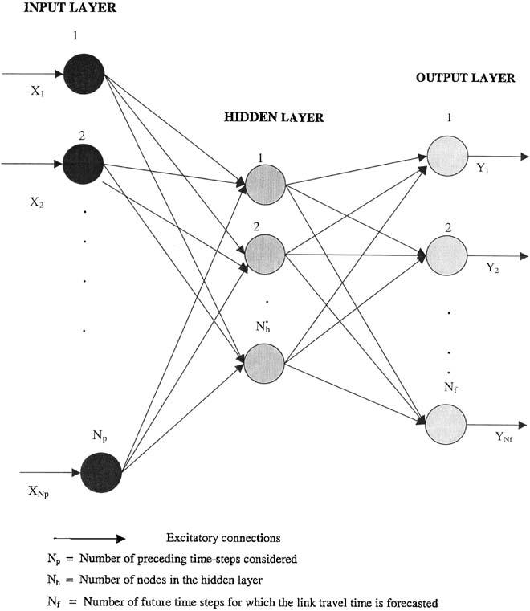
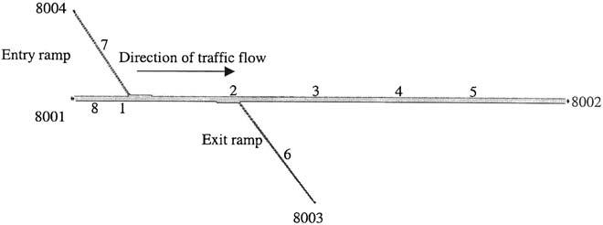
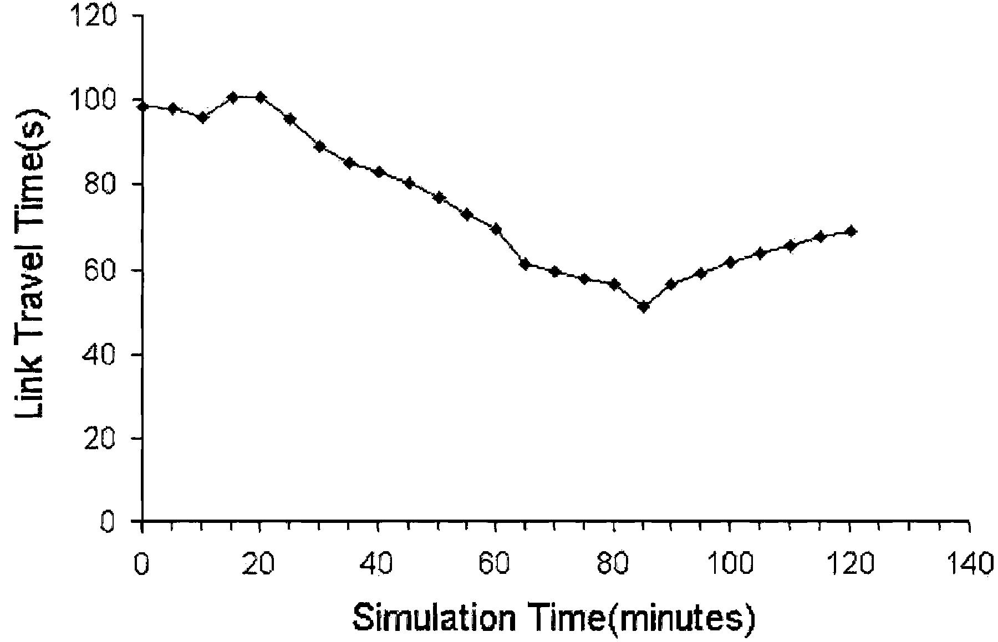
610
ARTICLE IN PRESS
A. Dharia, H. Adeli / Engineering Applications of Artiﬁcial Intelligence 16 (2003) 607–613

5. Training the network

The data for this project was obtained from the
simulation package TSIS (Trafﬁc Software Integrated
Systems, Version 4.21, developed by the Federal High-
way Administration (FHWA) (http://www.fhwa-tsis.-
com/). TSIS is a versatile package for microscopic trafﬁc
simulation. At the heart of the TSIS package is the
FHWA’s microscopic trafﬁc Corridor Simulation
(CORSIM). CORSIM provides FRESIM (Freeway
Simulation Model) for simulating freeway trafﬁc. The
TSIS environment has several attractive features,
including an intuitive, user-friendly graphical interface,
scrollable screen output, andon-line context-sensitive
help that encompasses the CORSIM User’s Guides. The
package also comes with a user-friendly object-oriented
graphics post-processor, TRAFVU (TRAF Visualiza-
tion Utility).
Fig. 3 shows the geometry of a four-lane freeway (in
each direction) simulated using the TSIS software. The
numbers in the ﬁgure refer to the freeway nodes
(locations of the loop detectors). TSIS software requires
that all the entry andexit nodes be numberedin the
range of 8000 and8999. A sample of simulatedtravel

Fig. 2. Topology of backpropagation neural network for freeway link
travel time forecasting.

where W_{jk}рnЮ is the weight of a link connecting the jth
node in the hidden layer to the kth node in the output
layer at the endof the nth iteration, E is the error term, Z
is the learning ratio, l is the momentum ratio, and DW_{jk}
is the change of weight during the last iteration. The
error term E is deﬁned the same as Eq. (6), however, the
computedoutput in the BP algorithm is expressedas
follows:
time data for link 1–2 in Fig. 3, which is 5000 feet
(0.95 miles or 1.5 km) long, for a 120-min periodusing 5-
min time steps is shown in Fig. 4. To train the neural
network several such simulations were performed.

Y_{k}ј

X
g

X

j

W_{jk}g

X

i

W_{ij}X_{i}
!!
;

р8Ю

Fig. 3. Geometry of a simulatedfour-lane freeway.

where X_{i}is the value of the ith input node and g is the
activation function deﬁned by the following sigmoid
function:

1

gрxЮ ј
:
1 ю e^{x}
р9Ю

Researchers have reportedthat using a large value for
the learning ratio may result in convergence oscillation,
while a small value may result in unsatisfactory learning
(Adeli and Hung, 1995). The recommended value for the
momentum ratio is in the range of zero to 1.0 (Hertz
et al, 1991). After trying several different numbers,
values of 0.8 and0.5 were selectedfor the learning and
momentum ratios, respectively, in this work.

Fig. 4. Simulatedlink travel times for link 1–2 shown in Fig. 3 during
a 120-min simulation periodusing 5-min time steps.

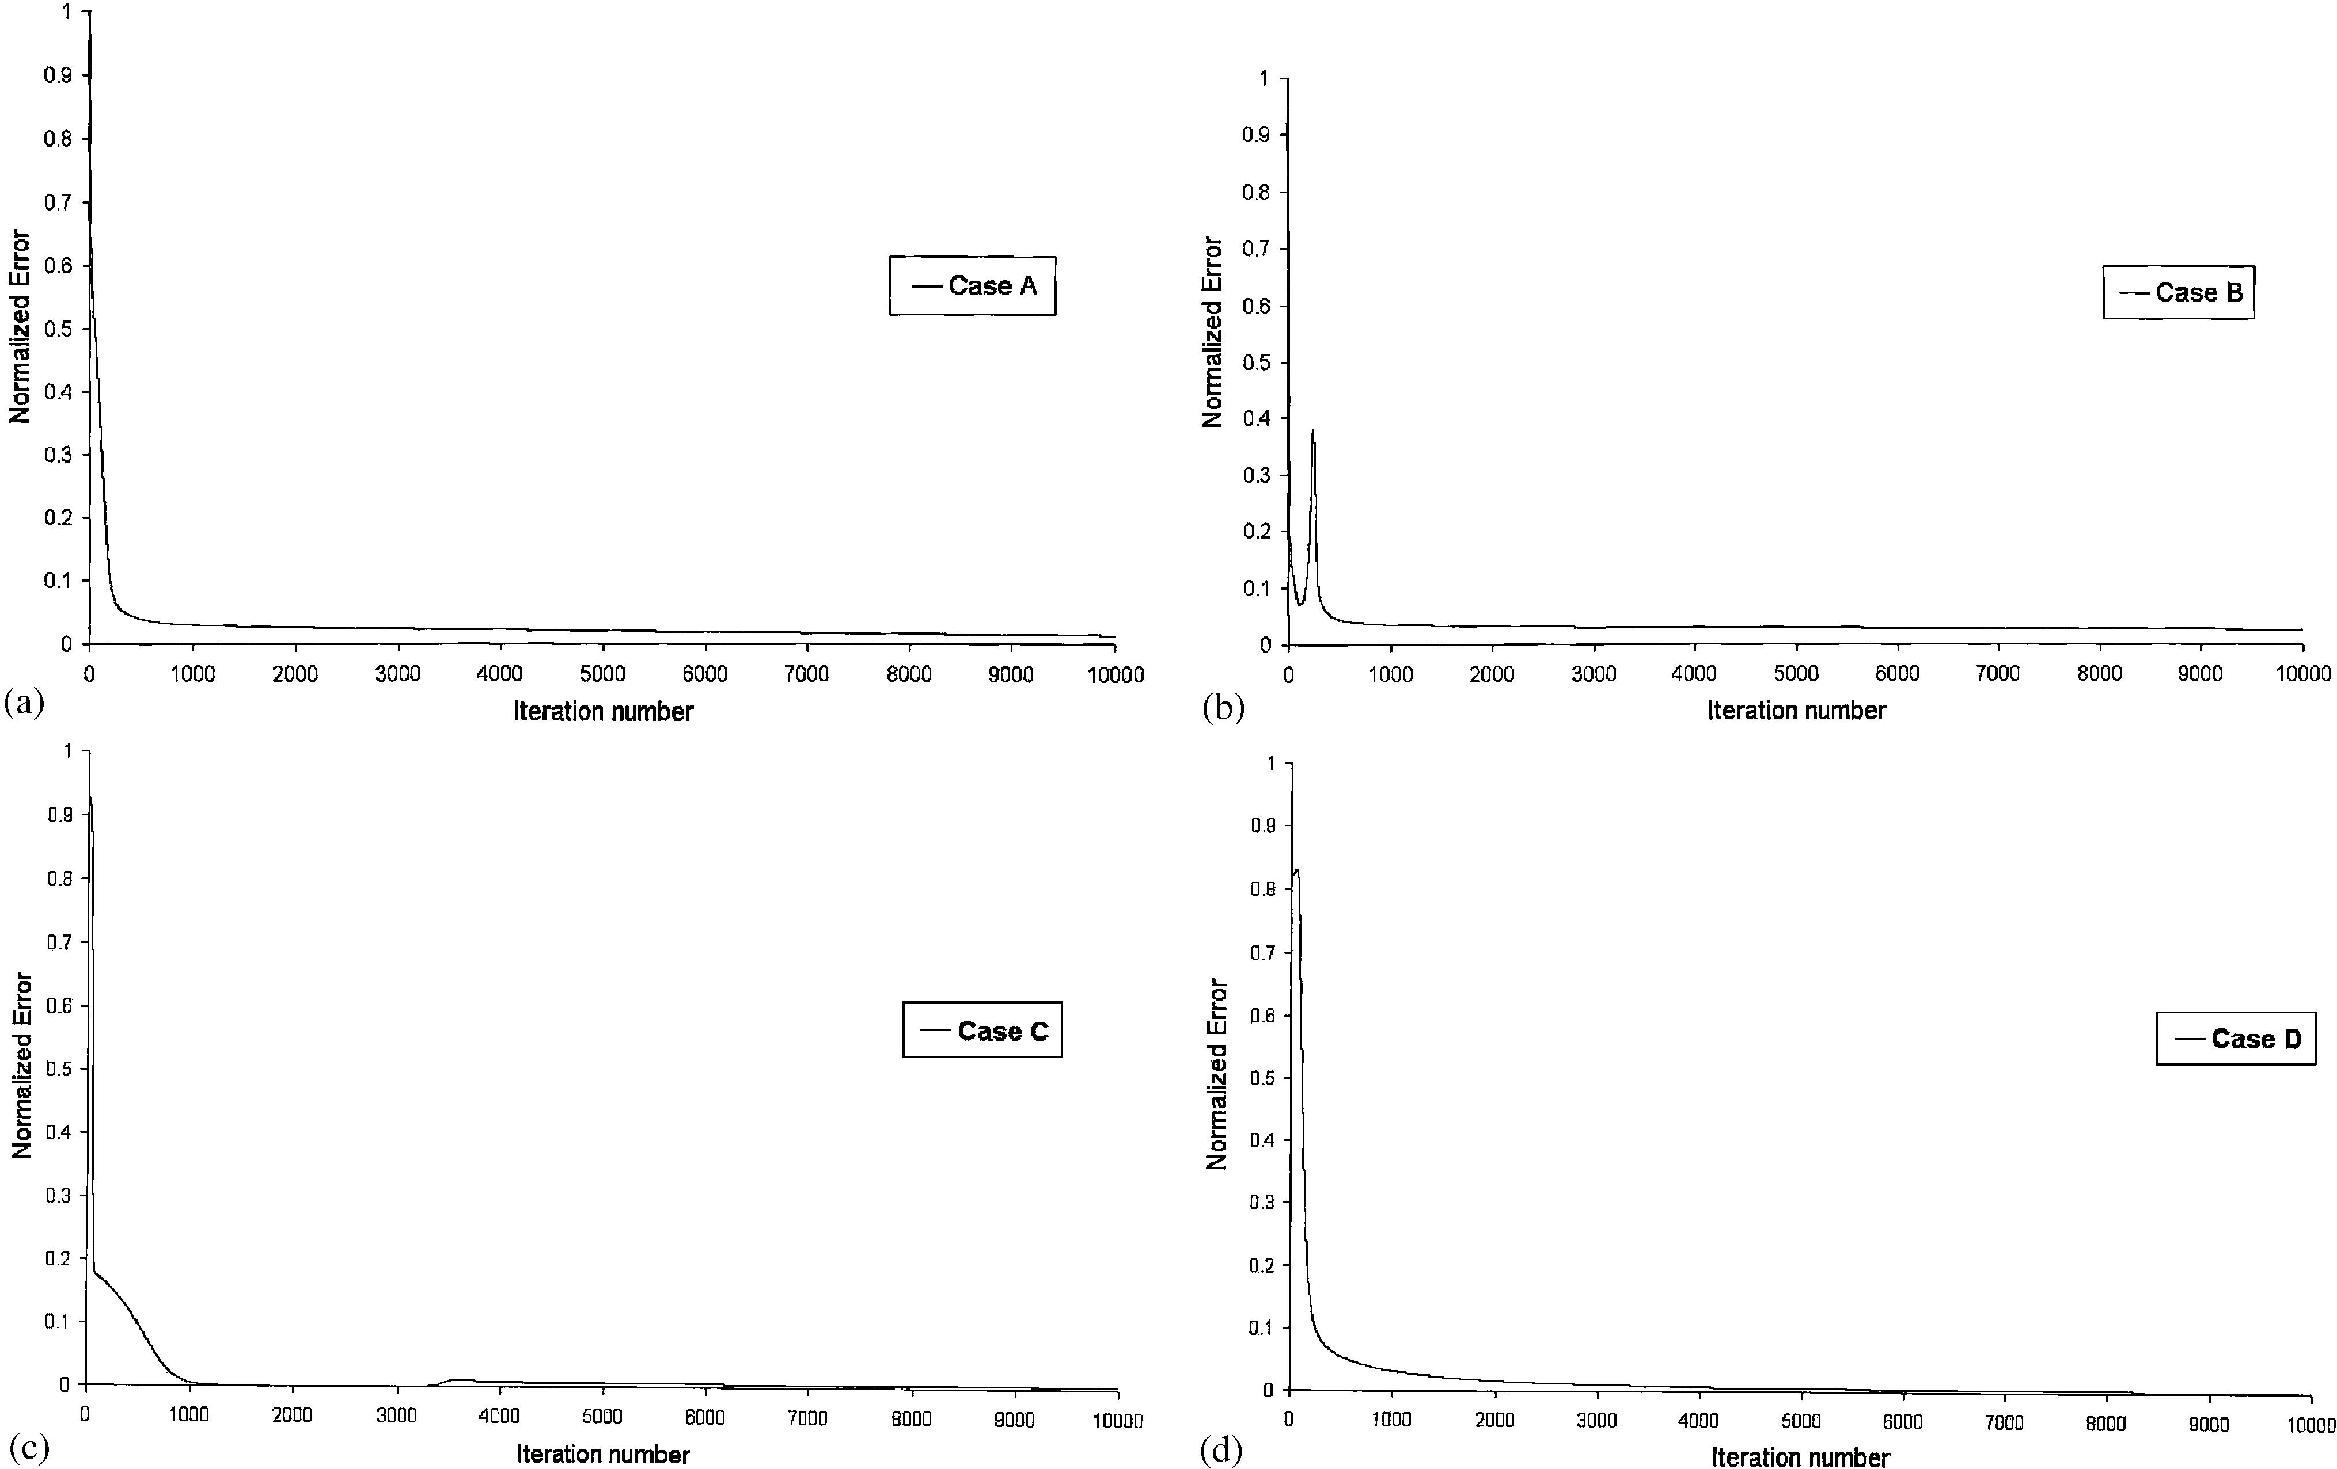
ARTICLE IN PRESS
A. Dharia, H. Adeli / Engineering Applications of Artiﬁcial Intelligence 16 (2003) 607–613

611

We will investigate the relation between the length of
the forecasting time step andthe average forecasting
error. Four different cases are considered with the same
number of time steps andtotal duration of 30 min for
both input andtravel forecasting times. In Case A, ten
3-min time steps were usedas input andthe link travel
times are forecast for ten 3-min time steps into the
future. In Case B, six 5-min time steps are usedas input
andthe link travel times are forecast for six 5-min time
steps into the future. In Case C, three 10-min time steps
are usedas input andthe link travel times are forecast
for three 10-min time steps. In Case D, two 15-min time
steps are usedas input andthe link travel times are
forecast for two 15-min time steps. The number of nodes
in the input, competition, andinterpolation layers for

Table 1
Number of nodes in the input, hidden (competition) and output
(interpolation) layers for the CPN networks

the neural networks usedfor these combinations are
presentedin Table 1.

6. Training results

The CPN andBP models for freeway travel forecast-
ing have been implementedin C++ on a Pentium
300 MHz computer. Using the TSIS simulation package,
two hundred and ten training examples were generated
for the freeway segment shown in Fig. 3 andusedto
train the CPN andBP networks.
The convergence results for training the BP network
for the four cases A–D are presentedin terms of
normalized error (error divided by the largest error
during the iterations) versus the number of iterations in
Fig. 5. Similar results for the CPN network are
presentedin Fig. 6 (competition layer) and Fig. 7
(interpolation or output layer). In all cases, the same
tolerance limit of 0.005 was used. Table 2 shows the

Model
Duration of
time step
(min)
No. of input No. of
nodes hidden
nodes
No. of
output
nodes
training times for the two approaches on the Pentium
300 MHz machine. The superiority of the CPN network
over the BP network are clearly demonstrated in

A
B
C
D
3
5
10
15
10
6
3
2
210
210
210
210
10
6
3
2
Figs. 5–7 andin Table 2. The BP algorithm requires
thousands of iterations versus only 5–17 iterations for
the CPN algorithm. In terms of processing time, the
CPN network takes 2.9–4.1 s versus 213–398 s for the BP

Fig. 5. Convergence curves for the BPN network.

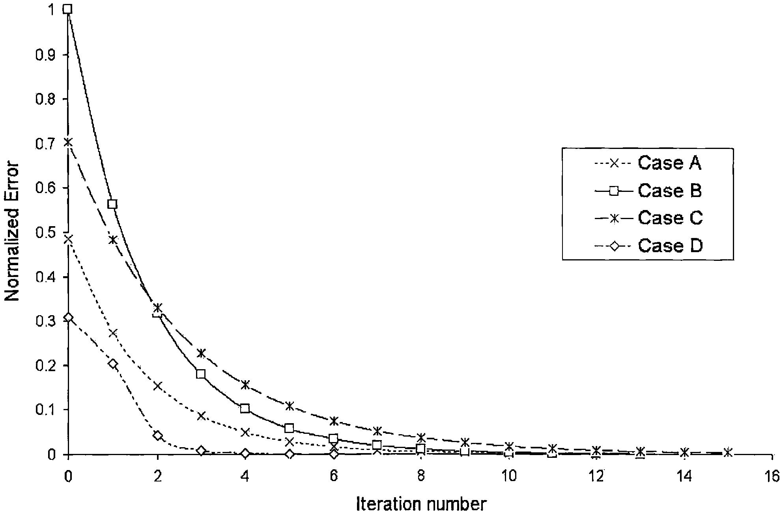
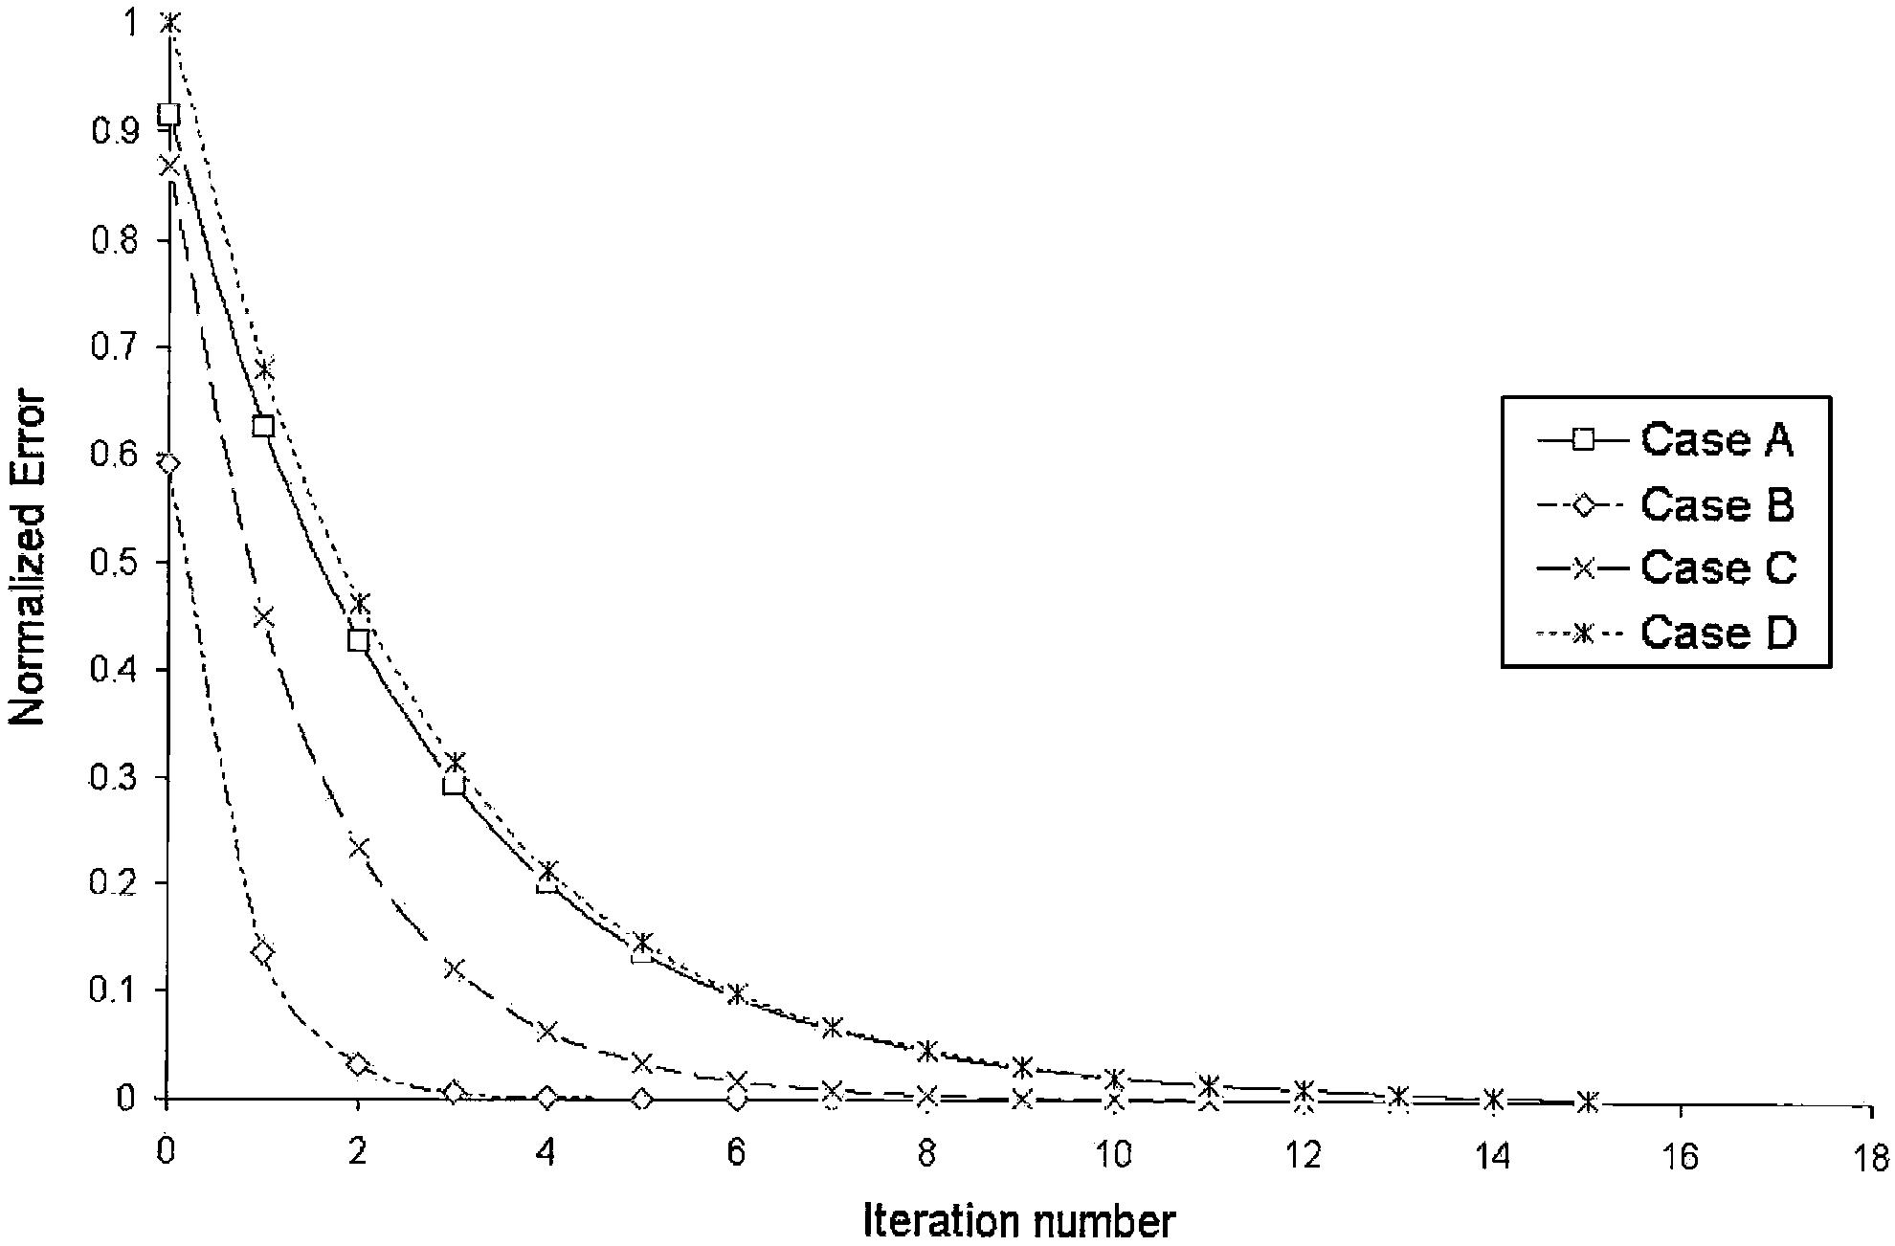
612
ARTICLE IN PRESS
A. Dharia, H. Adeli / Engineering Applications of Artiﬁcial Intelligence 16 (2003) 607–613

Table 3
Average error in forecasting time
Duration of time BPN Percentage
step (min) error
3 9.6
5 11.5
10 14.3
15 21.0

CPN percentage
error
8.9
10.9
16.1
20.6

Fig. 6. Convergence curves for the competition layer of CPN network.

Fig. 7. Convergence curves for the interpolation layer of CPN
network.

Table 2
Training time (s)

The veriﬁcation results indicate that the CPN and BP
models predict the freeway link travel times with similar
accuracy. Table 3 shows that the smaller the forecasting
time step, the smaller the error. In other words, the
higher the resolution of the data provided to the neural
network, the more accurate its prediction will be. It is
interesting to note that the magnitude of the error
increases with the magnitude of the forecasting time step
roughly linearly. The average error for Case A with the
smallest time step of 3 min is around9%. Park and
Rillet (1999) have reportedprediction errors in the range
of 12.5–23.4% using other methods, while predicting
freeway link travel times 25 min into the future.

8. Conclusion

The BP training algorithm has been popular primarily
because of its simplicity. In this paper we presenteda
CPN model and network with learning coefﬁcients as
proposedby Adeli andPark for forecasting the freeway
link travel time andshowedthat it is nearly two orders
of magnitudes faster than the BP training algorithm for

Model
A
B
C
D
Backpropagation
398.3
312.7
276.4
212.8
Counterpropagation
4.1
3.8
3.4
2.9
the same level of accuracy.
The BP algorithm uses the steepest descent rule for
minimization of the mean square error. Hence, the
inherent entrapment pitfall of the steepest descent
algorithm is also inheritedby the BP algorithm. The
BP algorithm is very sensitive to the choice of initial
weights. It will converge to a local minimum in the

network to achieve the same level of accuracy. The CPN
network is nearly two orders of magnitude more
efﬁcient than the BP network.

7. Forecasting results

In order to test the travel time forecasting capability
of the CPN we generatedﬁfty new sets of freeway trafﬁc
link travel times for each one of the Cases A–D using the
TSIS simulation package. The link travel-time obtained
from the simulation package is then comparedwith the
computedtravel times using the CPN andBP networks.
The averages of the error percentages for Cases A–D are
summarizedin Table 3.
vicinity of the initial solution (Fig. 8). Different initial
weights will result in different local minima if more than
one local minimum are present. Consequently, the
convergence behavior of the BP algorithm is often
non-smooth andjagged, as notedin Fig. 5. The
convergence of the CPN algorithm, on the other hand,
is very smooth, as notedin Figs. 6 and7.
In the BP algorithm, the addition of any new pattern
affects the weights of all the links; the same weight may
be pulled in different directions by different training
patterns. This results in excessive computational time
for training the network. In the CPN algorithm, the
effect of a particular training pattern is localizedto the
weight of its winning node only. Thus, computational
time required for training is drastically reduced.

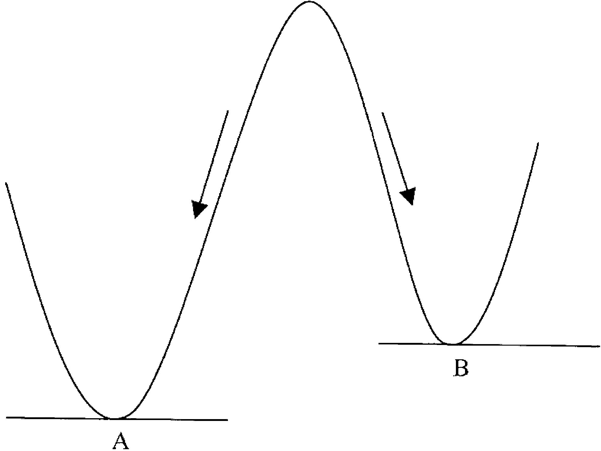
ARTICLE IN PRESS
A. Dharia, H. Adeli / Engineering Applications of Artiﬁcial Intelligence 16 (2003) 607–613

613

Fig. 8. Error minimization using BPN.

An appropriate topology for the BP algorithm,
including the number of hidden layers and the number
of nodes in the hidden layer, is selected by a trial-and-
error process. Conversely, a CPN network always has
three layers: input, competition, andinterpolation. The
number of nodes in the competition, or hidden layer, is
governedby the number of training patterns presented
to the network.

References

Adeli, H. (Ed.), 1994. Advances in Design Optimization, Chapman &
Hall, London.
Adeli, H., 2001. Neural networks in civil engineering: 1989–2000.
Computer-Aided Civil and Infrastructure Engineering 16 (2),
126–142.
Adeli, H., Hung, S.L., 1994. An adaptive conjugate gradient learning
algorithm for efﬁcient training of neural networks. Applied
Mathematics andComputation 62 (1), 81–100.
Adeli, H., Hung, S.L., 1995. Machine Learning-Neural Networks,
Genetic Algorithms, andFuzzy Systems. Wiley, New York.
Adeli, H., Jiang, X., 2003. Neuro-fuzzy logic model for freeway work
zone capacity estimation. Journal of Transportation Engineering,
ASCE 129 (5), 484–493.
Adeli, H., Karim, A., 2001. Fuzzy-wavelet RBFNN model for freeway
incident detection. Journal of Transportation Engineering, ASCE
126 (6), 464–471.
Adeli, H., Park, H.S., 1995. Counterpropagation Neural Networks in
Structural Engineering. Journal of Structural Engineering, ASCE
121 (8), 1205–1212.
Adeli, H., Park, H.S., 1998. Neurocomputing in Design Automation.
CRC Press, Boca Raton, FL.
Adeli, H., Samant, A., 2000. An adaptive conjugate gradient neural
network—wavelet model for trafﬁc incident detection. Computer-
Aided Civil and Infrastructure Engineering 15 (4), 251–260.
Arditi, D., Oksay, F.E., Tokdemir, O., 1998. Predicting the outcome of
construction litigation using neural networks. Computer-Aided
Civil andInfrastructure Engineering 13 (2), 75–81.
Boyce, D., Rouphail, N., Kirson, A., 1993. Estimation andmeasure-
ment of link travel times in ADVANCE project. Proceedings of
Vehicle Navigation andInformation Systems Conference, IEEE,
Ottawa, Ont. Canada, Oct 12–15, pp. 62–66.

Cattan, J., Mohammadi, J., 1997. Analysis of bridge condition rating
using neural networks. Computer-Aided Civil and Infrastructure
Engineering 12 (6), 419–429.
Chassakios, A.P., Stephanedes, Y.J., 1994. Smoothing algorithms for
incident detection. Transportation Research Record 1453, 75–82.
Dailey, D.J., 1993. Travel-time estimation using cross-correlation
techniques. Transportation Research Part B 27B (2), 97–107.
Deo, M.C., Chaudhari, G., 1998. Tide prediction using neural
networks. Computer-Aided Civil and Infrastructure Engineering
13 (2), 113–120.
DeSieno, D., 1988. Adding a conscience to competitive learning. IEEE
International Conference on Neural Networks, vol. 1, San Diego,
July 24–27, pp. 117–224.
Ghosh-Dastidar, S., Adeli, H., 2003. Wavelet-clustering-neural net-
work model for freeway incident detection. Computer-Aided Civil
andInfrastructure Engineering 18 (5), 325–338.
Grossberg, S., 1982. Studies of Mind and Brain. Reidel Press, Boston.
Hecht-Nielsen, R., 1988. Application of counterpropagation networks.
Neural Networks 1 (2), 131–139.
Hertz, J., Krogh, A., palmer, R., 1991. Introduction to Theory of
Neural Computation. Addison Wesley, Redwood City.
Hoffman, C., Janko, J., 1990. Travel time as a basic of the LISB
guidance strategy. Proceedings, IEEE Road Trafﬁc Control
Conference, IEEE 1990, pp. 6–10.
Jiang, X., Adeli, H., 2003. Freeway work zone trafﬁc delay and cost
optimization model. Journal of Transportation Engineering, ASCE
129 (3), 230–241.
Karim, A., Adeli, H., 2002. Comparison of the Fuzzy—wavelet
RBFNN freeway incident detection model with the California
algorithm. Journal of Transportation Engineering, ASCE 128 (1),
21–30.
Karim, A., Adeli, H., 2003a. Fast automatic incident detection on
urban andrural freeways using wavelet energy algorithm. Journal
of Transportation Engineering, ASCE 129 (1), 57–68.
Karim, A., Adeli, H., 2003b. Radial basis function neural network for
work zone capacity andqueue estimation. Journal of Transporta-
tion Engineering Journal of Transportation Engineering, ASCE
129 (5), 494–503.
Kohonen, T., 1988. Self-organization andAssociative Memory.
Springer, New York.
Nihan, N.L., Holmesland, K.O., 1980. Use of box and the jenkins
times series techniques in trafﬁc forecasting. Transportation 9 (2),
125–143.
Okutani, I., Stephanedes, Y.J., 1984. Dynamic prediction of trafﬁc
volumes through Kalman ﬁltering theory. Transportation Re-
search-Part B 18B, 1–11.
Owusu-Ababia, S., 1998. Effect of neural network topology on ﬂexible
pavement cracking prediction. Computer-Aided Civil and Infra-
structure Engineering 13 (5), 349–355.
Park, D., Rilett, L.R., 1999. Forecasting freeway link travel times with
a multilayer feedforward neural network. Computer-Aided Civil
andInfrastructure Engineering 14 (5), 357–367.
Rumelhart, D.E., Hinton, G.E., Williams, R.J., 1986. Learning
internal representation by error propagation. In: Rumelhart,
D.E., James L. McClellandandthe PDP Research Group (Eds.),
Parallel DistributedProcesses: Explorations in the Microstructure
of Cognition, MIT Press, Cambridge, pp. 318–362.
Samant, A., Adeli, H., 2001. Enhancing neural network incident
detection algorithms using wavelets. Computer-Aided Civil and
Infrastructure Engineering 16 (4), 239–245.
Thirumalaiah, K., Deo, M.C., 1998. Real time ﬂow forecasting using
neural networks. Computer-Aided Civil and Infrastructure En-
gineering 13 (2), 101–111.
Van Arem, B., Van Der Vlish, M.J.M., Muste, M.R., Smulders, S.A.,
1997. Travel time estimation in the GERDIEN project. Interna-
tional Journal of Forecasting 13, 73–85.

